FULL STACK DEVELOPMENT WITH MERN

PROJECT DOCUMENTATION

Introduction
- Project Title: Flight finder - Navigating your Air Travel Options
- Team id: LTVIP2026TMIDS24635
- Team Members:
- Team Leader: Jannu Shanmukha Veera Brahmam
- Team member: Vandamsetty Bindu Madhuri
- Team member: Kadali Pavan Ramu
- Team member: Udara Venkatesh

Project Overview
- Purpose:
The purpose of the FlightFinder project is to address the challenges faced by users in traditional flight booking systems, such as fragmented information, time-consuming comparisons, and lack of transparency in pricing.
The key objectives of this project are:
- To provide a centralized platform for flight search, comparison, and booking
- To reduce user effort and decision-making time through smart filtering and recommendations
- To enable flight agencies to manage and publish flight details efficiently
- To ensure data authenticity and trust through admin approval mechanisms
- To deliver a secure, scalable, and user-friendly flight booking experience
By achieving these objectives, FlightFinder aims to enhance user satisfaction, improve operational efficiency, and offer a reliable solution for navigating modern air travel options.

Features:
    - Search and filter flights
    - Book tickets with user login
    - Admin panel for managing flights
    - Email confirmation
    - Booking history

Architecture

Frontend:

Built with React.js using components, hooks, and React Router for navigation. UI powered by Material-UI.

Backend:

Developed using Node.js and Express.js. RESTful API handles all CRUD operations related to users, flights, and bookings.

Database:
MongoDB stores user data, flight details, and booking records. Mongoose is used for schema design and data validation.
Frontend (React.js) Components:
- Search Page: Handles user inputs such as source, destination, and travel date.
- Flight List Page: Displays available and ranked flight results.
- Booking Page: Allows users to enter passenger details and confirm bookings.
- Admin Dashboard: Enables approval of agencies and flight listings.
Backend (Node.js/Express.js) API Routes: javascript app @app.route('/search', methods=['GET'])
def search_flights():
@app.route('/book', methods=['POST'])
def book_flight():
Middleware:
- Authentication and authorization using Flask-Login / JWT
- Input validation and session management
Database (MongoDB) Schemas: javascript
const User = new Schema({ email: { type: String, unique: true },
bookings: [{ type: Schema.Types.ObjectId, ref: 'Booking' }]
});

Setup Instructions

Prerequisites
- Node.js >= 18
- MongoDB installed and running
- npm or yarn Installation
- git clone
https://github.com/your-username/FlightFinder.git

- cd FlightFinder
- cd server
- npm install

- cd ../client
- npm install

Environment Variables:
Create a .env file in the /server folder with:
PORT=3000
MONGODB URI-
mongodb+srv://bindu:<db_password>@cluster0.zghkpqk.mongodb.net/?retryWrit
es=true&w=majority&appName=Cluster0

5. Folder Structure
  - Client:
/client
├── /src
│ ├── /components
│ ├── /pages
│ ├── /api
│ ├── App.js
│ └── index.js

  - Server:
/server
├── /controllers
├── /routes
├── /models
├── server.js
└── .env
6. Running the Application
Frontend:
  - cd client
  - npm start
Backend:
  - cd server
  - npm start

API Documentation
  - POST /api/auth/register
Registers a new user.
Request Body: { name, email, password }
Response: { success, token }
  - POST /api/auth/login Logs in an existing user.

GET /api/flights
Retrieves list of available flights.

POST /api/bookings
Books a flight for the logged-in user.

Authentication
  - Implemented using JWT (JSON Web Token).
  - Tokens are stored in HTTP-only cookies.
  - Protected routes validate tokens before granting access.

User Interface
Home Page with flight search
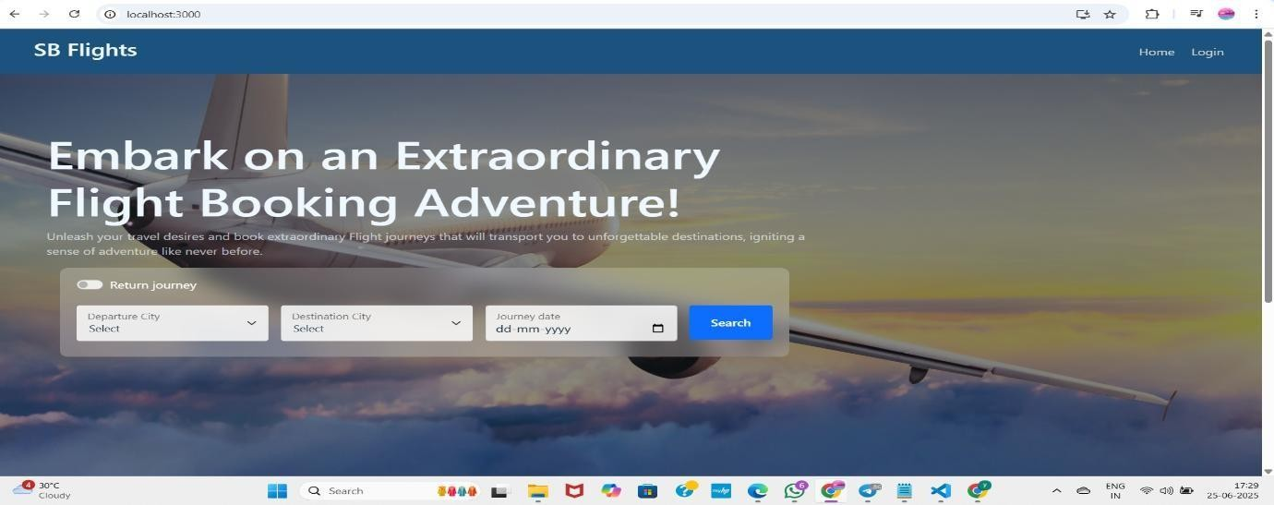
Login form
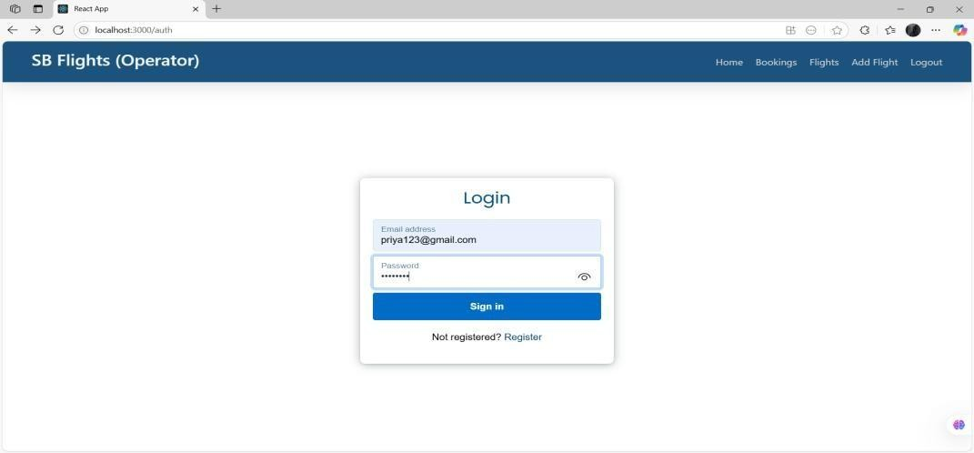

Register form
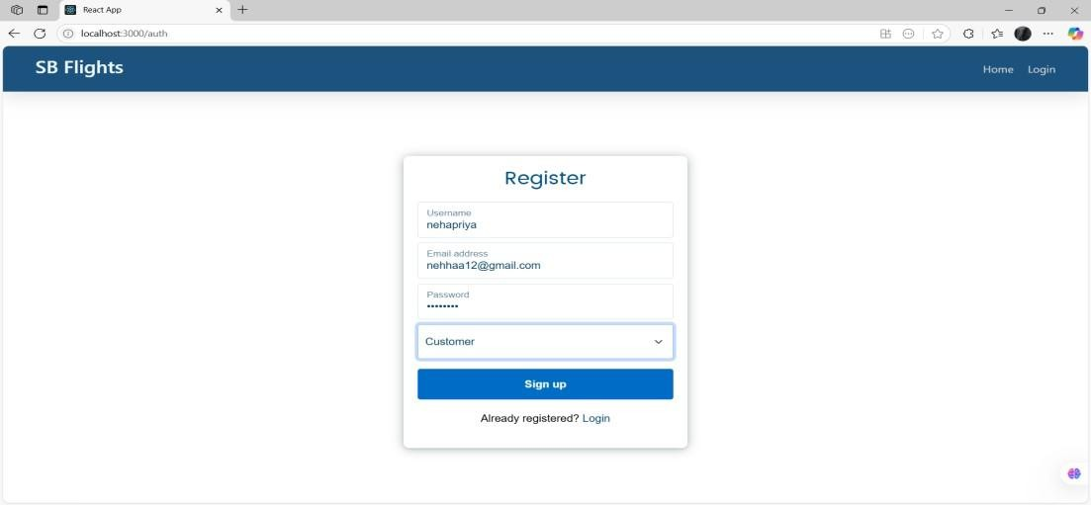
Admin dashboard
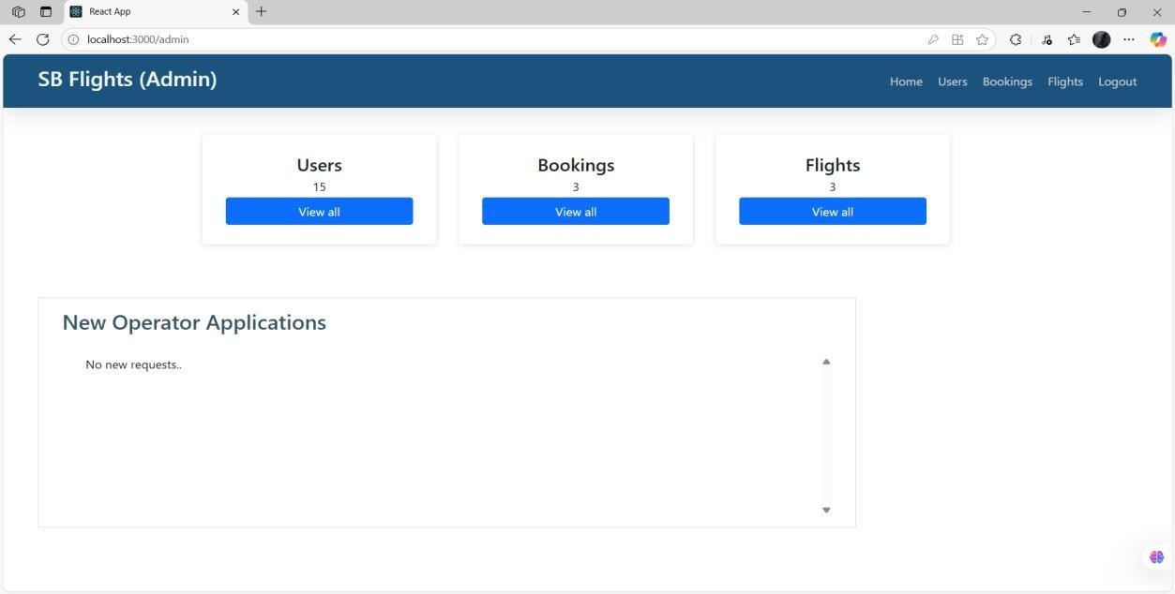

Booking confirmation page
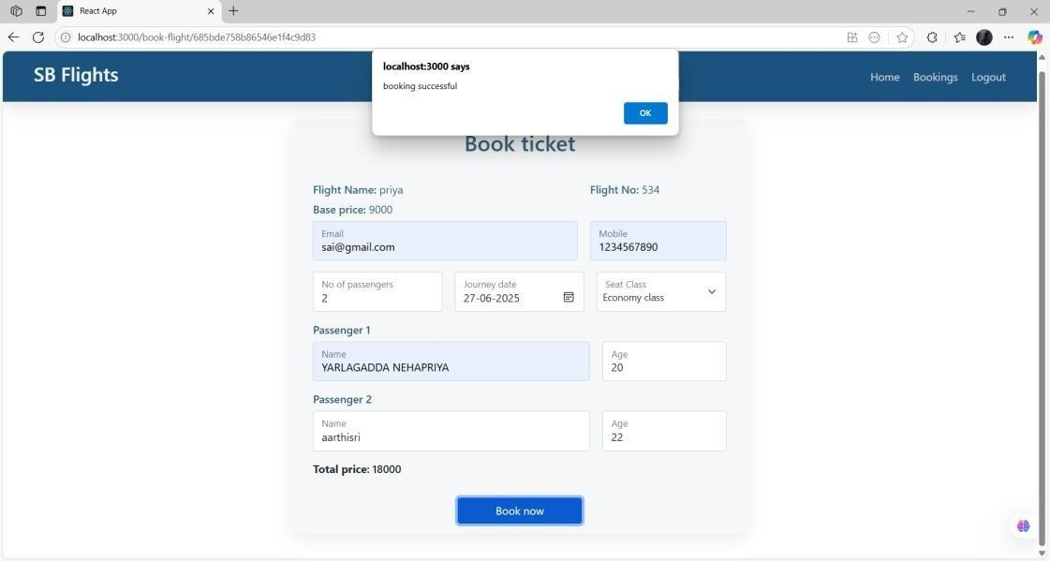
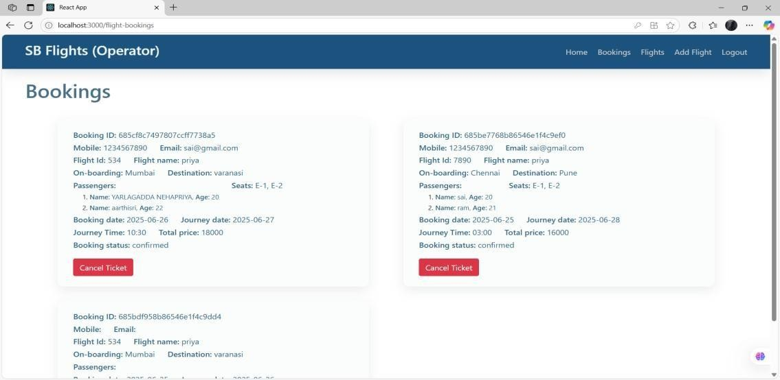

Testing
  - Manual testing on Postman for backend APIs
  - Basic component tests in React using Jest and React Testing Library

Demo Link:
https://drive.google.com/file/d/1zip8WSxf9lR-jd4uo2Y-x4vG0q1cmLQm/view

Known Issues
  - No password recovery implemented yet
  - UI responsiveness needs improvement on tablets

Future Enhancements
  - Payment integration with Razorpay/Stripe
  - Role-based admin access
  - Real-time flight tracking integration

